Exam Type: Final/End Term Paper Course: - G.Science – GSC101

Total Marks: - -60 Paper time: 90 minutes

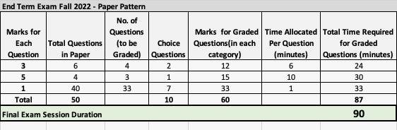
Note: The syllabus of Final/End term is video lecture # 19 to 45.
MCQ#1 Which of the following bond is made up of a large number of organic compounds?
- Metallic bond
- Dipolar bond
- Ionic bond
- Covalent bond
MCQ#2 Which of the following is not a class of organic compounds?
- Amides
- Electro compounds
- Nitro compound
- Carbonyl compound
MCQ#3 Which of the following is a classification of Organic compounds?
- Alicyclic compounds and acyclic compounds
- Cyclic compounds and alicyclic compounds
- Open chain compounds and acyclic compounds
- Open chain compounds and linear chain compounds
MCQ#4 How many lone pairs of electrons does O atom have in methanol?
- 0
- 1
- 2
- 4
MCQ#5 If A and B are the C-O bond lengths in methanol and phenol respectively, what is the relationship between A and B?
- A>B
- A<B
- A=B
- A≥B
MCQ#6 Dehydration of Alcohol is an example of______.
- Addition reaction
- Elimination reaction
- Substitution reaction
- Redox reaction
MCQ#7 Which of the following is true?
- Lower alcohols are liquid at room temperature and the higher ones are solid
- Lower alcohols and higher alcohols, both are liquid at room temperature
- Higher alcohols are liquid at room temperature and the lower ones are solid
- Both lower and higher alcohols are solid at room temperature
MCQ#8 Galvanisation is a method of protecting iron from rusting by coating it with a thin layer of ______.
- Galium
- Aluminium
- Zinc
- Silver
MCQ#9 The poorest conductor of heat among metals is ______.
- Mercury
- Lead
- Calcium
- Sodium
MCQ#10 The most abundant metal in the earth’s crust is ______.
- Iron
- Calcium
- Aluminium
- Sodium
MCQ#11 What is the charge on the copper ion in the mineral azurite, Cu₃(CO₃)₂(OH)₂?
- 2+
- 1+
- 0
- 1-
MCQ#12 In the process known as 'roasting,' a(n) _____ is chemically converted to a(n) _____.
- Sulfide; oxide
- Carbonate; oxide
- Hydroxide; oxide
- Oxide; sulfate
MCQ#13 Which of the following is an example of corrosion?
- Rusting of iron
- Tarnishing of silver
- Liquefaction of ammonia
- Rusting of iron and tarnishing of silver
MCQ#14 Leakage of inflammable gas from a corroded pipe can cause ___________.
- Acidity
- Alkalinity
- Turbidity
- Fire hazards
MCQ # 15 Which of the Halogens is found in liquid state at room temperature ?
- Chlorine
- Iodine
- Astatine
- Bromine
MCQ#16 Genetic material is contained within the ___ of the cell.
- Ribosomes
- Cytoplasm
- Nucleus
- Lysosomes
MCQ#17 Which structure is directly responsible for the formation of proteins within the cell.
- Lysosomes
- Vacuoles
- Ribosomes
- Centrioles
MCQ#18 In which stage of meiosis does synapsis take place?
- Leptotene
- Pachytene
- Zygotene
- Metaphase I
MCQ#19 In which stage of mitosis the spindle fibre are formed and get attached to the chromosomes?
- Metaphase
- Anaphase
- Prophase
- Telophase
MCQ#20 Chromatin contains:
- DNA+RNA
- RNA+Histones
- DNA+Histones
- DNA+RNA+Histones
MCQ#21 Gametes formation takes place through which process?
- Fission
- Meiosis
- Mitosis
- Amitosis
MCQ#22 Spicy food, coupled with anxiety, may lead to ________.
- Indigestion
- Hypotension
- Seizures
- None of the above
MCQ#23 An individual’s blood is classified as _________ if an inherited protein is found on the surface of the blood cells.
- ANA-Positive
- Rh-Neutral
- Rh-Negative
- Rh-Positive
MCQ#24 Which of the following pairs has a double circulation pathway?
- Amphibians and Mammals
- Birds and Mammals
- Reptiles and Mammals
- Fishes and Birds
MCQ#25 Which blood group has no antibody?
- O
- AB
- A
- B
MCQ#26 In human being the duration of cardiac cycle is ___________.
- 0.008 sec
- 0.5 sec
- 0.8 sec
- 8 sec
MCQ#27 The volume of blood each ventricle pumps out during a cardiac cycle is about ___________.
- 70 ml
- 5000 ml
- 7 L
- 1200 ml
MCQ#28 In Earthworms, the process of respiration is through ________.
- Skin
- Head
- Lungs
- Pores on its anterior end
MCQ#29 In which part of the respiratory system, gaseous exchange takes place?
- Alveoli
- Pharynx
- Larynx
- Trachea
MCQ#30 This artery passes blood to the kidney ________.
- Common iliac
- Cystic
- Renal
- Coeliac
MCQ#31 This is the functional unit of the kidney ________.
- Hilum
- Neurons
- Nephrons
- Medulla
MCQ#32 Which among the following is known as a Secondary Pollutant in the atmosphere?
- Ozone
- Sulfur dioxide
- Nitrogen Oxides
- Carbon Monoxide
MCQ#33 The largest ecosystem of earth is ________.
- Biosphere
- Hydrosphere
- Lithosphere
- Biome
MCQ#34 In a food chain of grassland ecosystem the top consumers are
- Herbivorous
- Carnivorous
- Bacteria
- Either carnivorous or herbivorous
MCQ#35 The order of organism in an aquatic food chain is ________.
- Bacteria > Seal > Diatom > Fish > Crustacea
- Crustacea > Seal > Fish > Polar Bear > Diatom
- Polar Bear > Diatom > Seal > Crustacea
- Diatom > Crustacea > Fish > Seal > Bacteria
MCQ#36 A plant being eaten by a herbivorous which in turn is eaten by a carnivorous makes ________.
- Food chain
- Food web
- Omnivorous
- Interdependent
MCQ#37 In a food chain herbivores are ________.
- Primary producers
- Primary consumers
- Secondary consumers
- Decomposers
MCQ#38 Which must be preserved in an ecosystem, if the system is to be maintained?
- Producers and carnivores
- Producers and decomposers
- Carnivores and decomposers
- Herbivores and carnivores
MCQ#39 The first process in extraction of an element from ore is typically
- Roasting
- Electrolysis
- Crushing
- Smelting
MCQ#40 Composition up to 0.008% carbon is considered as _________.
- Pure iron
- Steel
- Cast iron
- Annealed steel

Here are some sample questions of 3 marks:

Question 1: Explain why SO₃ gas is dissolved in H₂SO₄ , but not in water in contact process?
Question 2: What factors are most likely to affect the breathing rate?
Question 3: Why are some compounds that contain carbon not considered as organic compounds?
Question 4: What are pulmonary veins? How many are there?

Here are some sample questions of 5 marks :

Question 1:State the causes and treatment for the following diseases
1-Tuberculosis 2-Pneumonia 3-Bronchitis
Question 2: Explain the open circulatory and closed circulatory systems and also the advantages of a closed circulatory system over an open circulatory system?
Question 3: Labeled the given diagram and answer the following questions
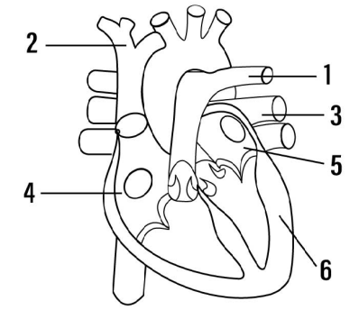
- Which type of blood is carried by the blood vessel marked 2 ?
- Name the main artery which takes the blood from heart to different parts of the body ?

